בס"ד

**דוח פרויקט במבנה נתונים - 2**

**SELECT Queries:**

1- average soldiers per brigade:

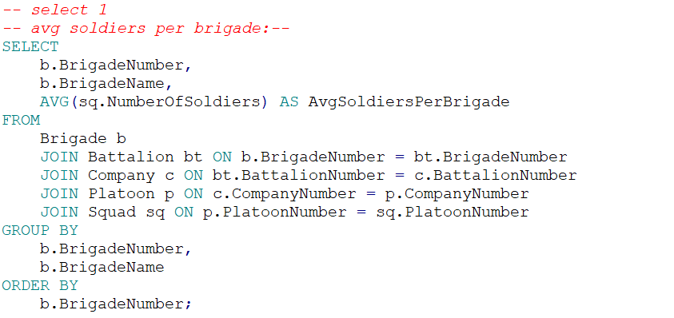

Explanation:

This query calculates the average number of soldiers per brigade. It does so by joining the `Brigade`, `Battalion`, `Company`, `Platoon`, and `Squad` tables to gather the necessary data, then grouping the results by `BrigadeNumber` and `BrigadeName`. The final result is ordered by `BrigadeNumber` to present the brigades in ascending order.

Output:  
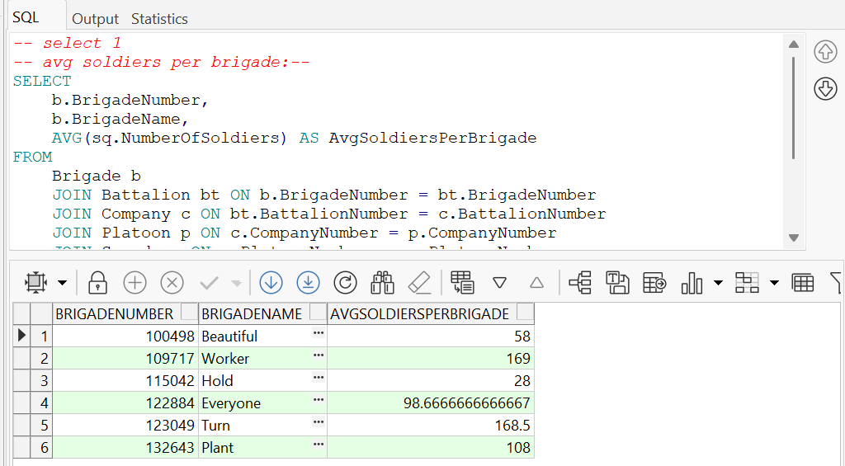

2- Top battalions with highest average of soldiers per squad:

-- select 2

--gives the 5 battalion's with the highest average number of soldiers per

--squad and breaks down the deployment date into day, month, and year.

--(could be a couple of battalions with the same avg)

SELECT

    bt.BattalionNumber,

    bt.BattalionName,

    AVG(sq.NumberOfSoldiers) AS AvgSoldiersPerSquad,

    EXTRACT(DAY FROM s.DeploymentDate) AS DeploymentDay,

    EXTRACT(MONTH FROM s.DeploymentDate) AS DeploymentMonth,

    EXTRACT(YEAR FROM s.DeploymentDate) AS DeploymentYear

FROM

    Soldier s

    JOIN Squad sq ON s.SquadNumber = sq.SquadNumber

    JOIN Platoon p ON sq.PlatoonNumber = p.PlatoonNumber

    JOIN Company c ON p.CompanyNumber = c.CompanyNumber

    JOIN Battalion bt ON c.BattalionNumber = bt.BattalionNumber

GROUP BY

    bt.BattalionNumber,

    bt.BattalionName,

    s.DeploymentDate

HAVING

    AVG(sq.NumberOfSoldiers) IN (

        SELECT * FROM (

            SELECT AVG(sq2.NumberOfSoldiers) AS AvgSoldiersPerSquad

            FROM

                Battalion bt2

                JOIN Company c2 ON bt2.BattalionNumber = c2.BattalionNumber

                JOIN Platoon p2 ON c2.CompanyNumber = p2.CompanyNumber

                JOIN Squad sq2 ON p2.PlatoonNumber = sq2.PlatoonNumber

            GROUP BY

                bt2.BattalionNumber

            ORDER BY

                AVG(sq2.NumberOfSoldiers) DESC

        ) WHERE ROWNUM <= 5

    )

ORDER BY

    AvgSoldiersPerSquad DESC,

    s.DeploymentDate;

Output:

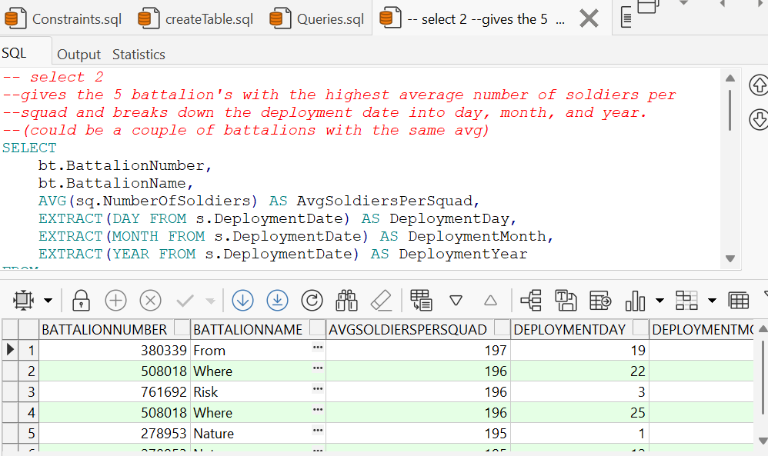

Explanation:

This query identifies the top five battalions with the highest average number of soldiers per squad, breaking down the deployment date into day, month, and year. It first calculates the average number of soldiers per squad for each battalion, then selects the top five battalions based on this average. The query also includes deployment date details and orders the results by the average number of soldiers per squad and deployment date.

3- number of soldiers per company, by rank and deployment date and rank:

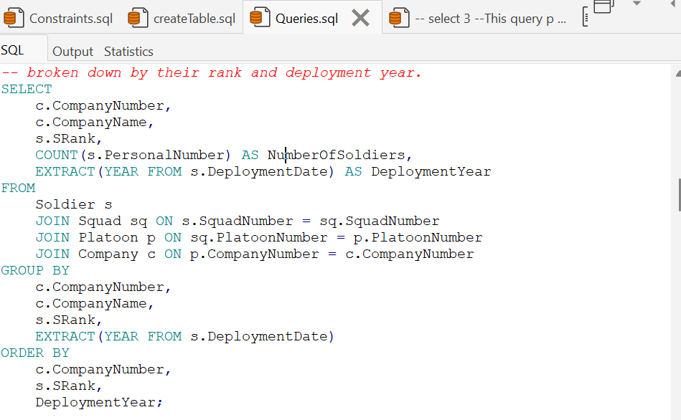

Output:

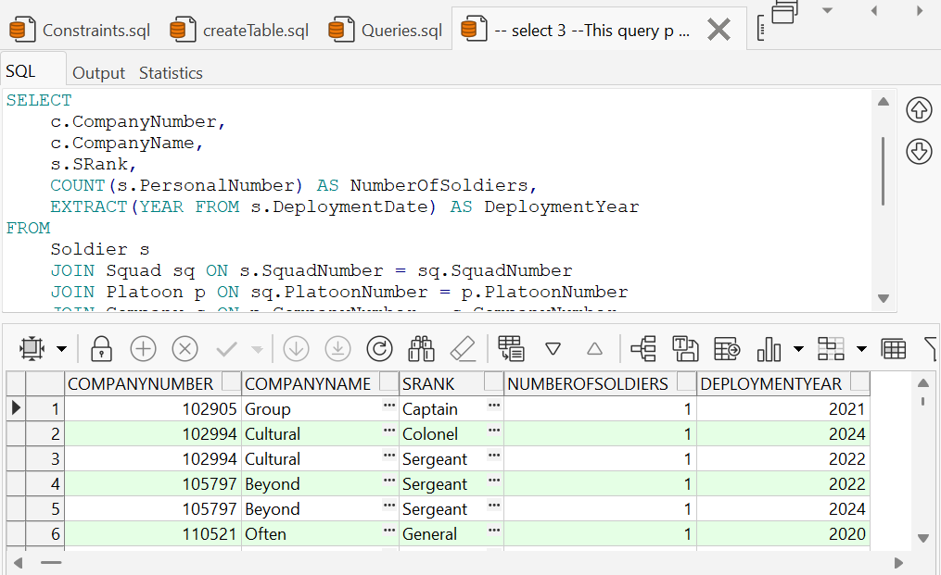

Explanation:

This query counts the number of soldiers in each company, grouped by their rank and the year of deployment. It joins the `Soldier`, `Squad`, `Platoon`, and `Company` tables to gather the necessary data, then groups the results by company number, company name, soldier rank, and the year of deployment. Finally, the results are ordered by company number, soldier rank, and deployment year, providing a detailed breakdown of the soldier distribution within each company.

4- lists all soldiers that were deployed in the past year grouped by brigade and sorted by deployment date:

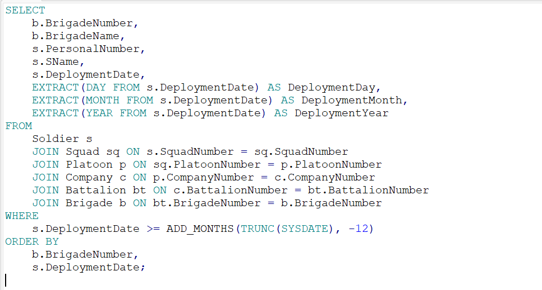

Output:

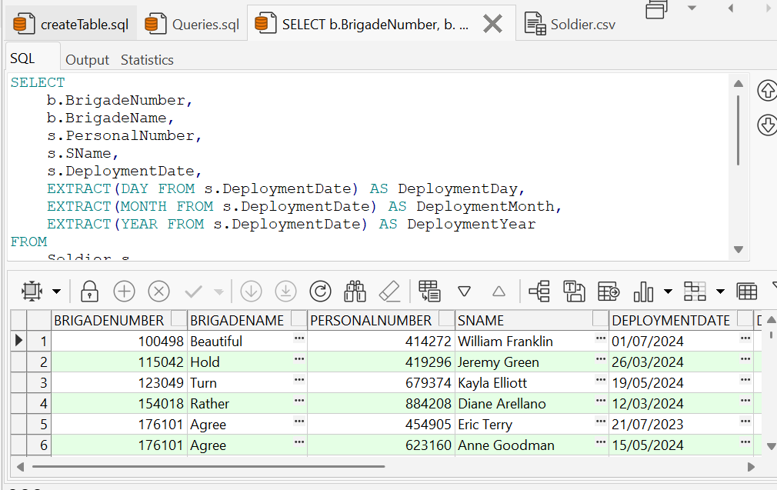

Explanation:

This query retrieves details about soldiers who were deployed in the last 12 months, including their brigade information and deployment date broken down into day, month, and year. It joins the `Soldier`, `Squad`, `Platoon`, `Company`, `Battalion`, and `Brigade` tables to gather the necessary data, then filters the results to include only those soldiers whose deployment date is within the last 12 months. The results are ordered by brigade number and deployment date, providing a detailed and timely breakdown of recent deployments across brigades.

**PARAM – Queries**

1. 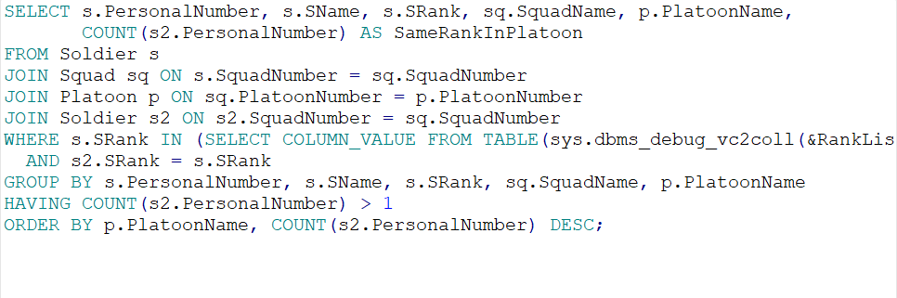Query that shows soldiers of specified ranks, their squad and platoon, and counts how many soldiers of the same rank are in their platoon, only showing results where there's more than one soldier of that rank in the platoon.

Output:

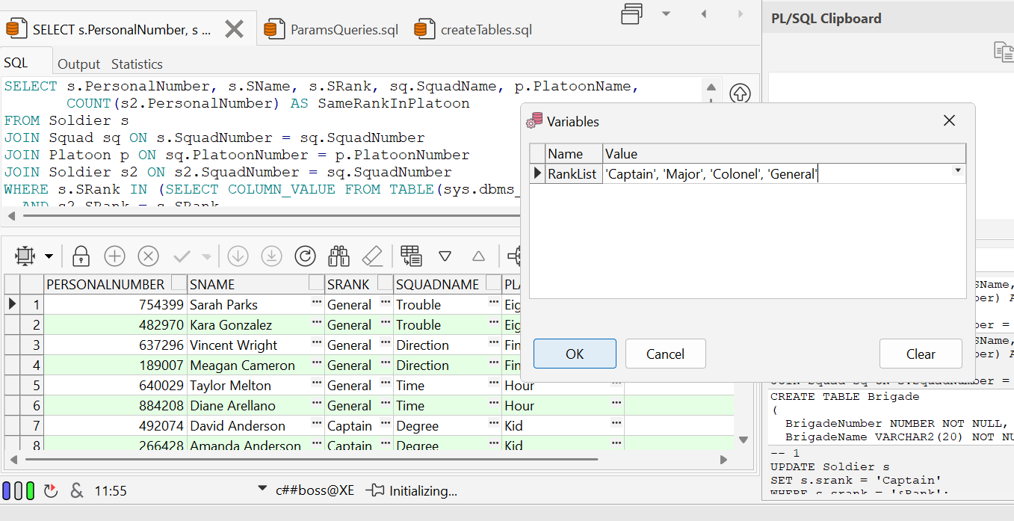

Explanation:

By a given list of ranks the query shows soldiers of specified ranks, their squad and platoon, and counts how many soldiers of the same rank are in their platoon, only showing results where there's more than one soldier of that rank in the platoon.

1. Query returns details of soldiers from a given start and end date:

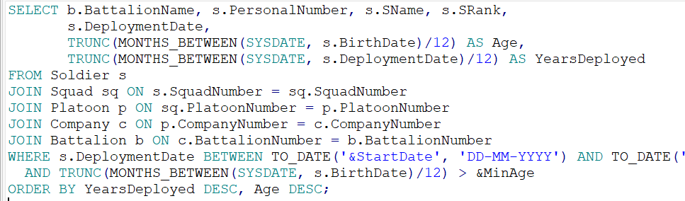

Output:

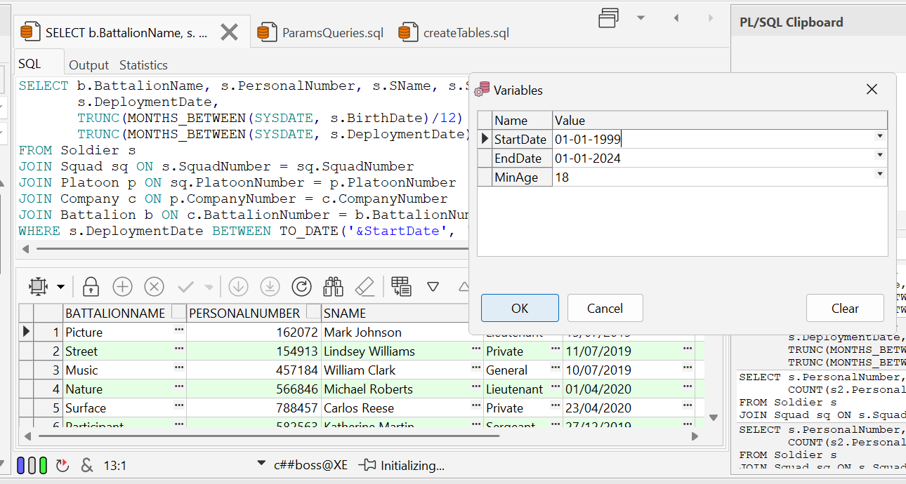

Explanation:

This SQL query retrieves details of soldiers, including their battalion, personal number, name, rank, deployment date, age, and years deployed, filtering by deployment date range and minimum age. It orders the results by the number of years deployed and age, both in descending order.

1. query retrieves information about a specific soldier and their company filtering by the first letter of the soldier’s name, excluding certain ranks, and only including companies with more than a specified minimum size.

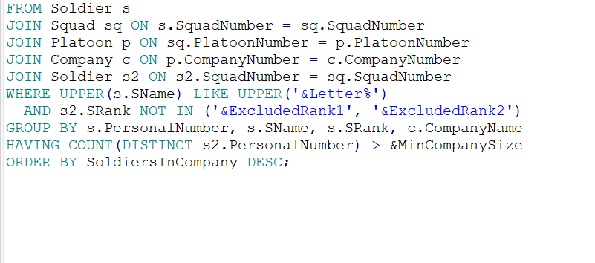

Output:

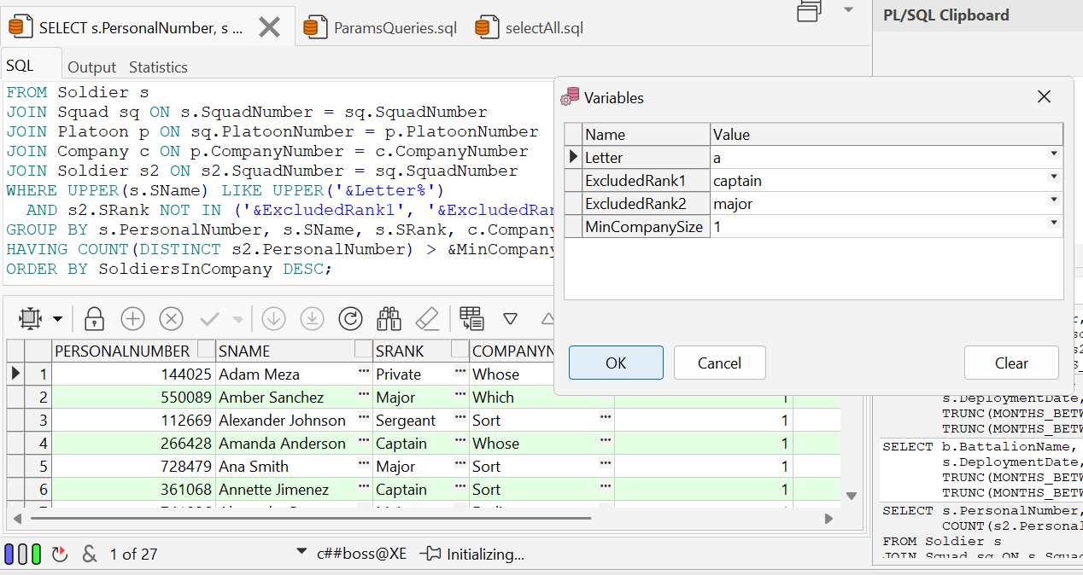

Explanation:  
 A query retrieves details about soldiers whose names start with a specified letter, along with statistics about their company, excluding certain ranks, and only includes companies with more than a specified minimum size.

1. A query that returns information of soldiers if their numbers is divisible by a given number and the soldier isn’t of the given excluded ranks:

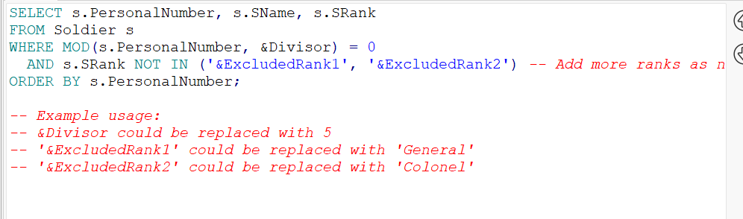

Output:  
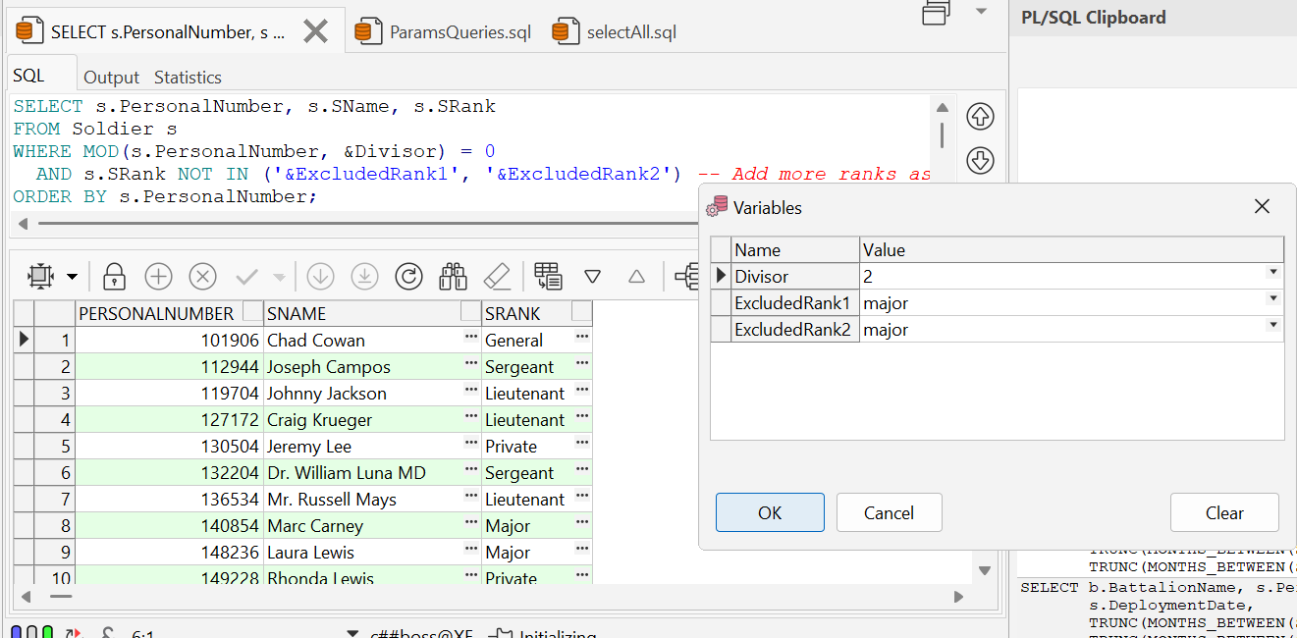

Explanation: filters out the soldier numbers by mod, and then goes one by one and filters out the given ranks.

**DELETE – Querys**

1. Deletes soldiers that are in squads in less then avg soldier per squad:

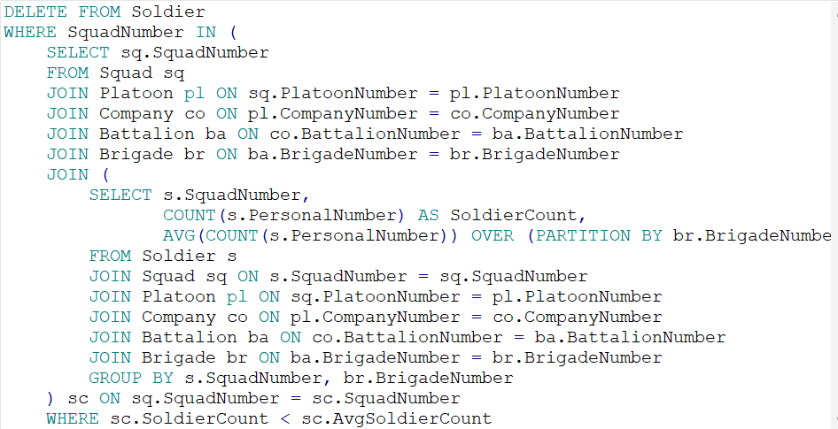

Output:

Before:

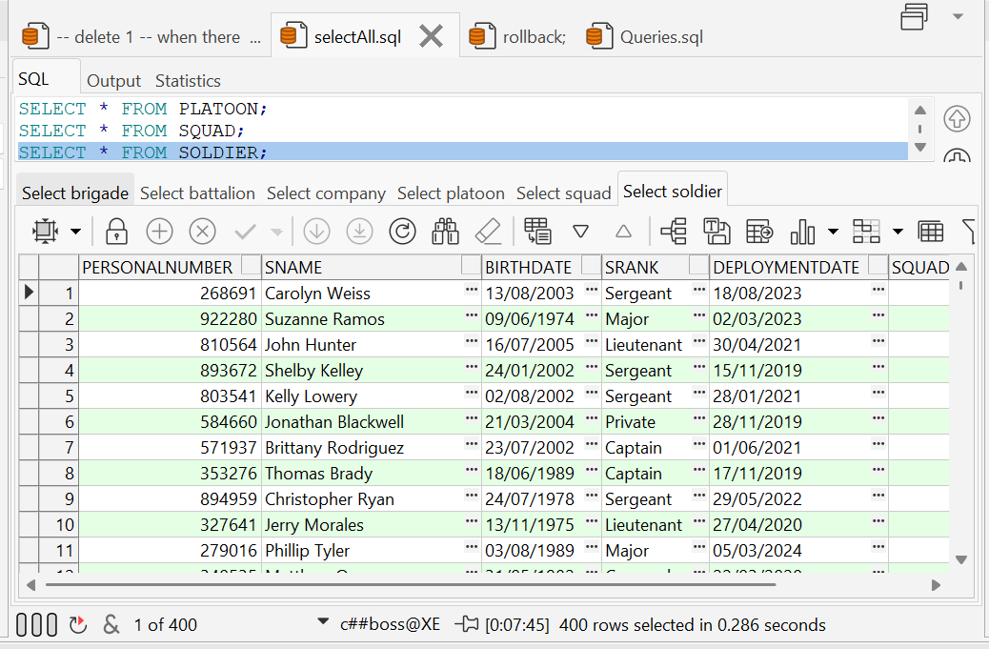



After:

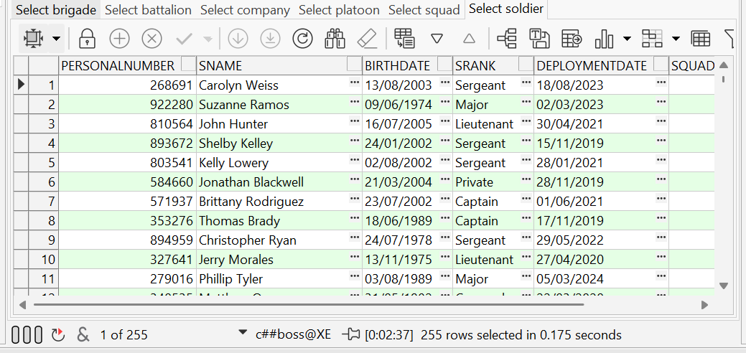



Explanation: Calcs avg then checks what squads have lower than avg and deletes the soldiers of those squads.

1. Deletes lowest ranked soldiers in smallest squads:  
   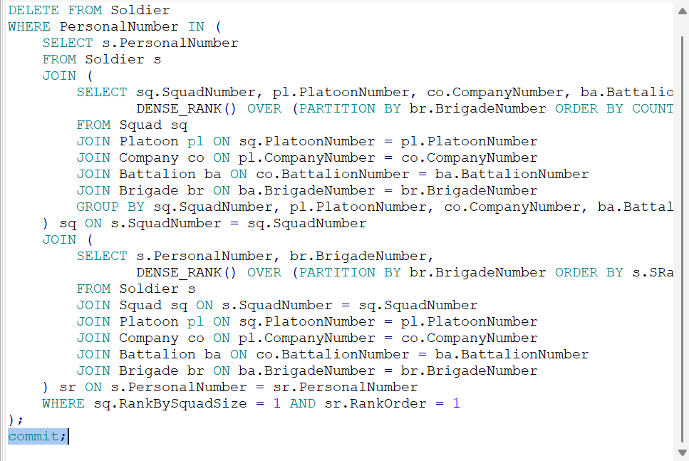

Output:  
Before:  
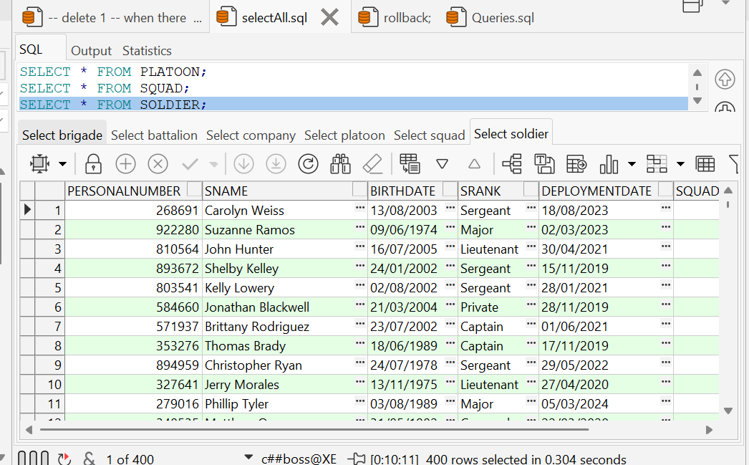



After:  
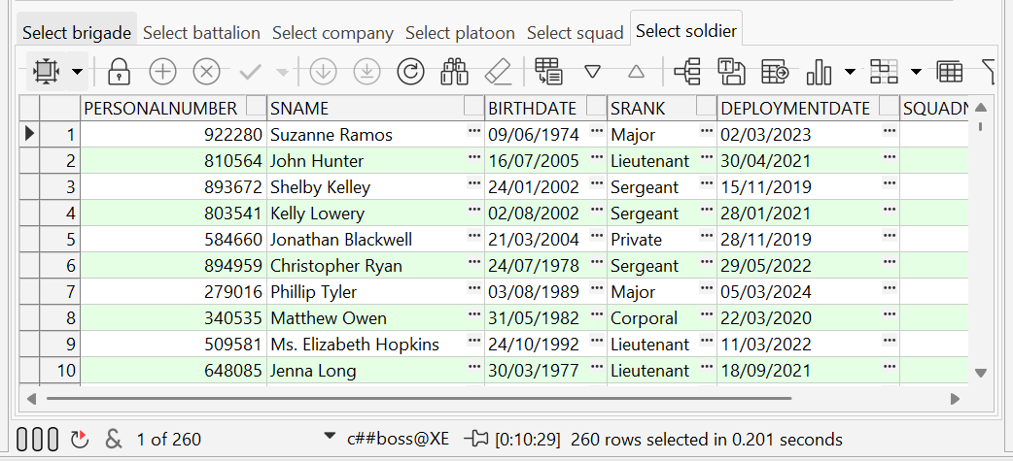



Explanation:

Checks smallest squads and deletes the lowest ranked soldiers.

**UPDATE-Quarys**

1. Updates the soldiers of the biggest platoons and that were born before 1999:

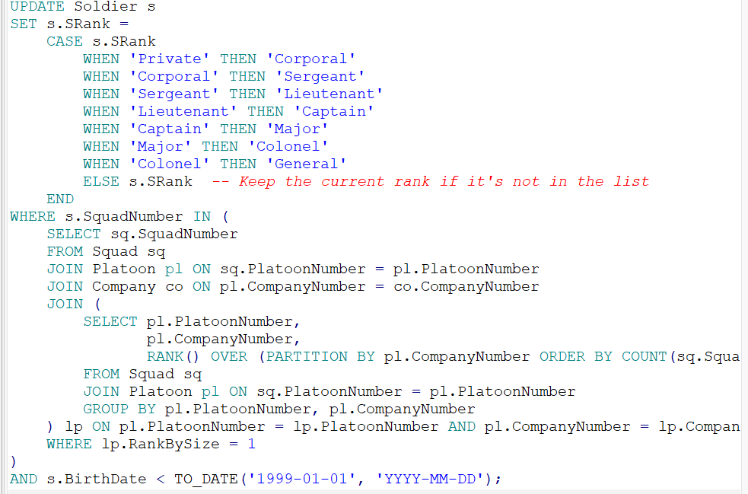

Output:  
 before: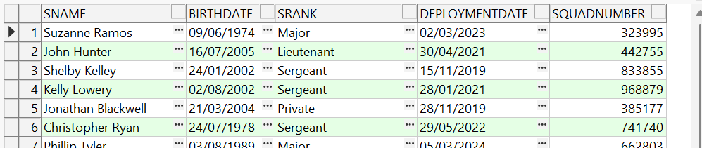



After:  
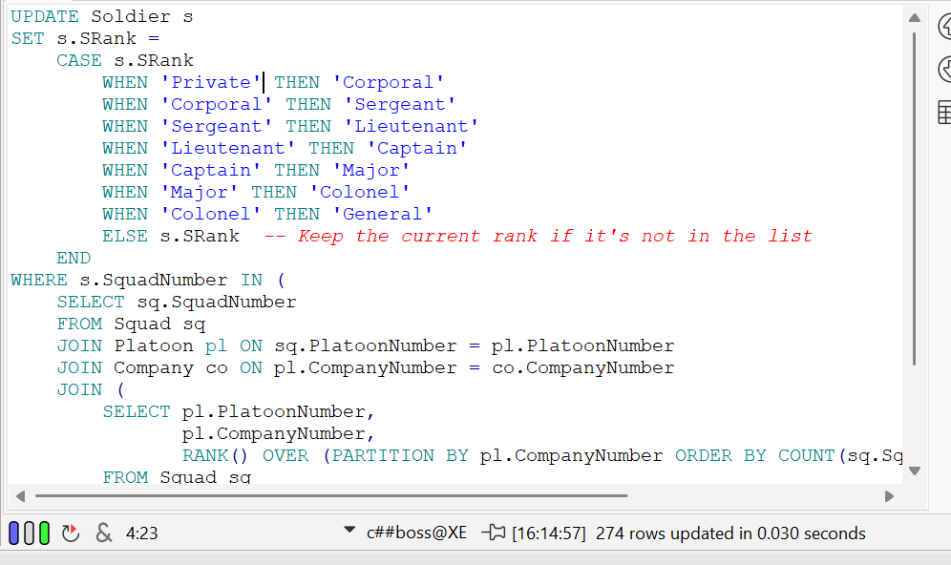



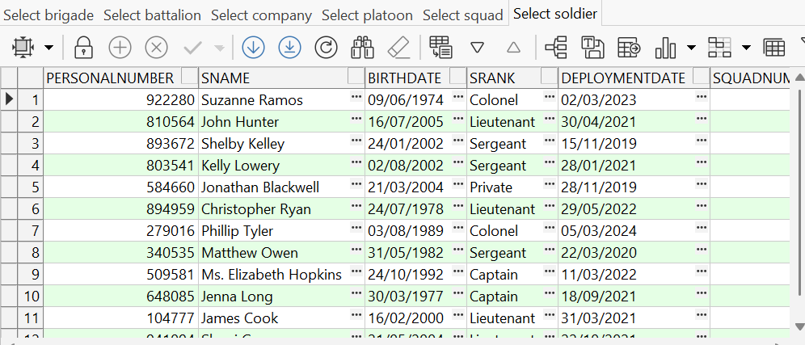



Explanation:

This query promotes soldiers born before 1999 who are in the largest platoon of each company to the next rank in the military hierarchy, using a CASE statement to determine the new rank based on their current rank.

1. Updates the deployments date of soldiers in companies that have more than 2 platoons

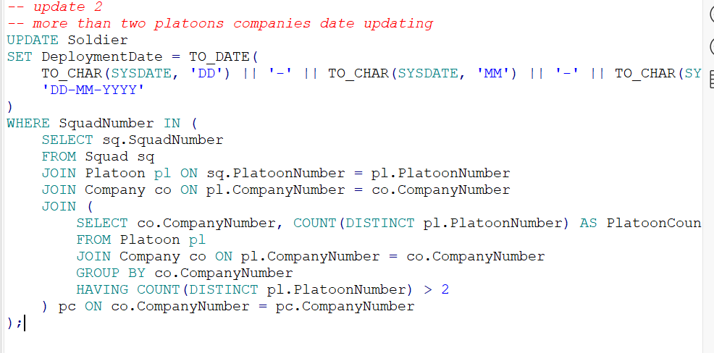

Output:  
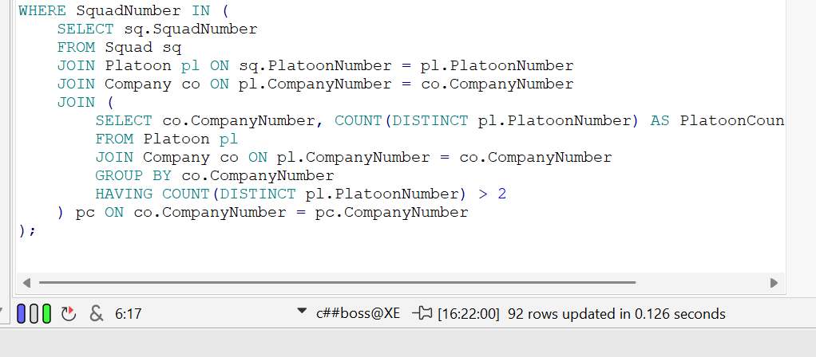



**CONSTRAINT – Querys**

1. 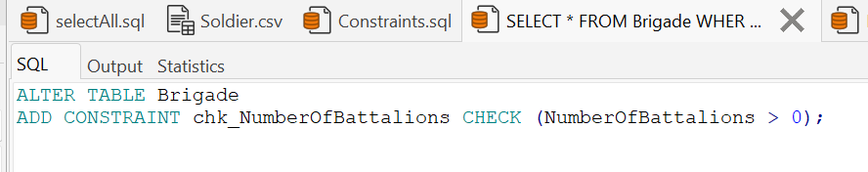Number of Battalions in Brigade is bigger than 0:

Attempt to contradict:

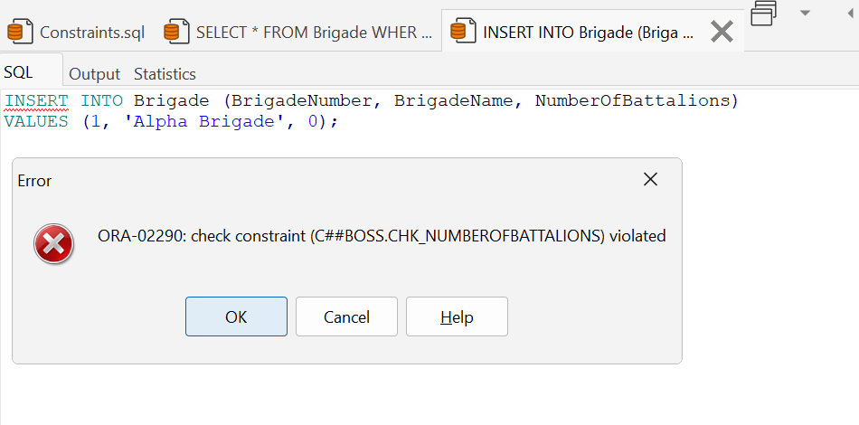

1. Makes sure that no new soldiers are added that there is less than 18 years between their birthday and deployment date.

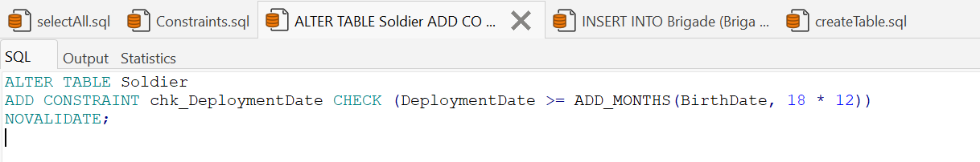

Attempt to contradict:

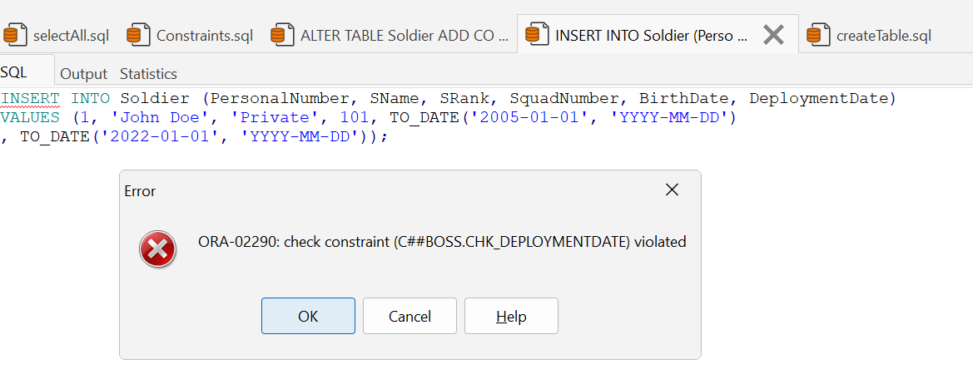

1. Make sure that there are at least 3 squads in every platoon:

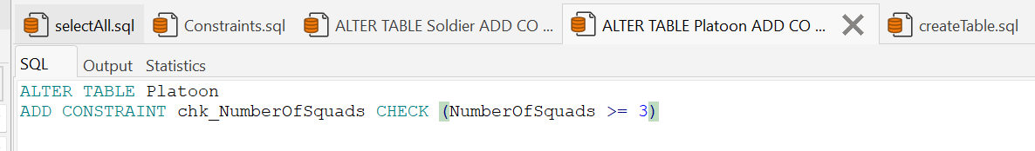

Attempt to contradict:  
